Process Name: | Transfer a Student (Outside of School District)
Last Updated: | 04/25/2017 12:04 PM
Initial Author: | Mary-Jo MacRae (EECD)
Last Updated by: | Cynthia Gilks MacInnis (ASD-N)
Time period(s) most often used: | September-June

Transfer a Student (Outside of School District)
When students leave your school to attend another school outside of your district, or outside of the province of New Brunswick use the Transfer Out of School function.

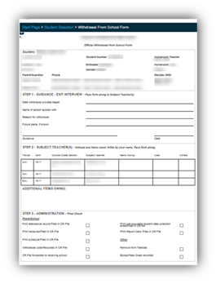
When you transfer a student out of your school, the student’s records become inactive at your school. Student records are not deleted; their status just changes to inactive. Inactive students normally will not appear in search results or students lists.
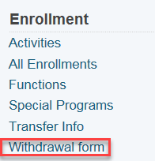
Prior to starting the Transfer process please make sure the Withdrawal Form has been printed and completed. To retrieve the withdrawal form select student on start page. Enrollment>Withdrawal Form

Use the NB Report Period Attendance by Class and run it for the individual student who is transferring for the date range the student attended your school. This report can be printed and should be added to the Cumulative Record. A job aid for creating this report is found in Data Connect.

Before starting the final withdrawal process (as described under the title “Sending School”) please attend to the following detail as it relates to your student’s grade level:
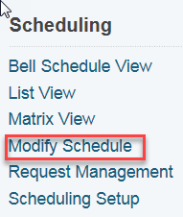
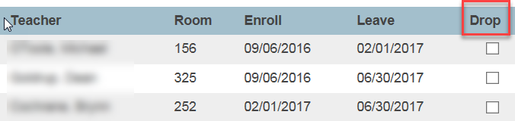
- K to 8 – make sure that courses are dropped using Modify Schedule. Start Page>Student Name>Modify Schedule

- 9 to 12 – Two steps. The second step has 2 parts:
Step 1: Courses are dropped using Modify Schedule Start Page>Student Name>Modify Schedule

Step Two (2 parts) Part 1: Open term in the upper right hand corner of the start page. Select the upcoming year. In the example the upcoming year (i.e. next school year) is 17-18.
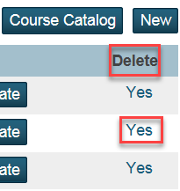
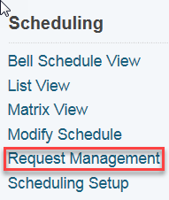
Part 2: Clear the future requests for the upcoming year. In upcoming year: Start Page>Student Name>Request Management> Modify Schedule-Requests. Reminder: return to the current school term after this is finished and in order to proceed with the transfer

Please ensure the steps up to this point have been completed prior to proceeding with the actual transfer OUT

AAs in K-Gr 8 Schools: Provide teacher with Excel spreadsheet found on Data Connect titled: Transfer template K-8 by grade level and program of study. Teachers are asked to complete this and for the information to be included and kept in the Cumulative Record.

The Parent/Guardian notifies the school that student will be transferring to another school outside of the school district. The AA then completes a Transfer OUT as follows:

Transferring Out

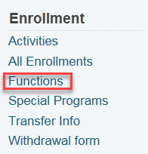
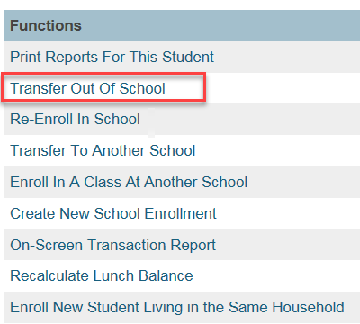
1. On the Start Page search for and select the student
2. Click Functions on the left side of the screen under Enrollment
3. Click Transfer Out of School under Functions

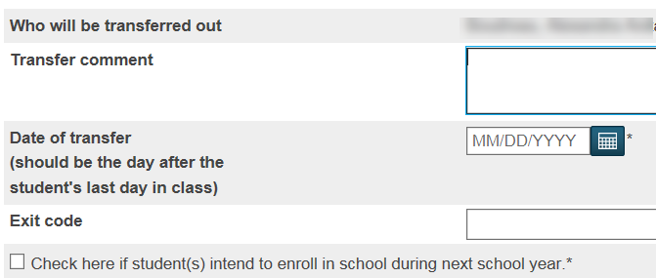
4. Enter comments concerning the transfer
5. Enter the day after the student was last in school for the Exit Date
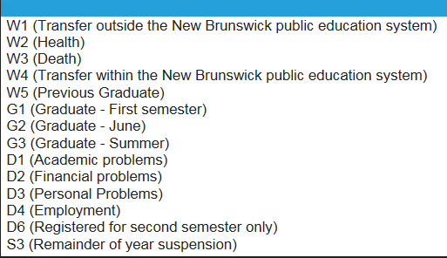
6. Choose the appropriate exit code (Click drop down Menu arrow)
7. Do not check the box below the exit code
8. Click Submit

Helpful Searches
Start Page>

Student Name “Searches for the specific student who is active”
/student name “Searches for specific student who is inactive”

